2022/ 2023 School Year
English 1 HONORS
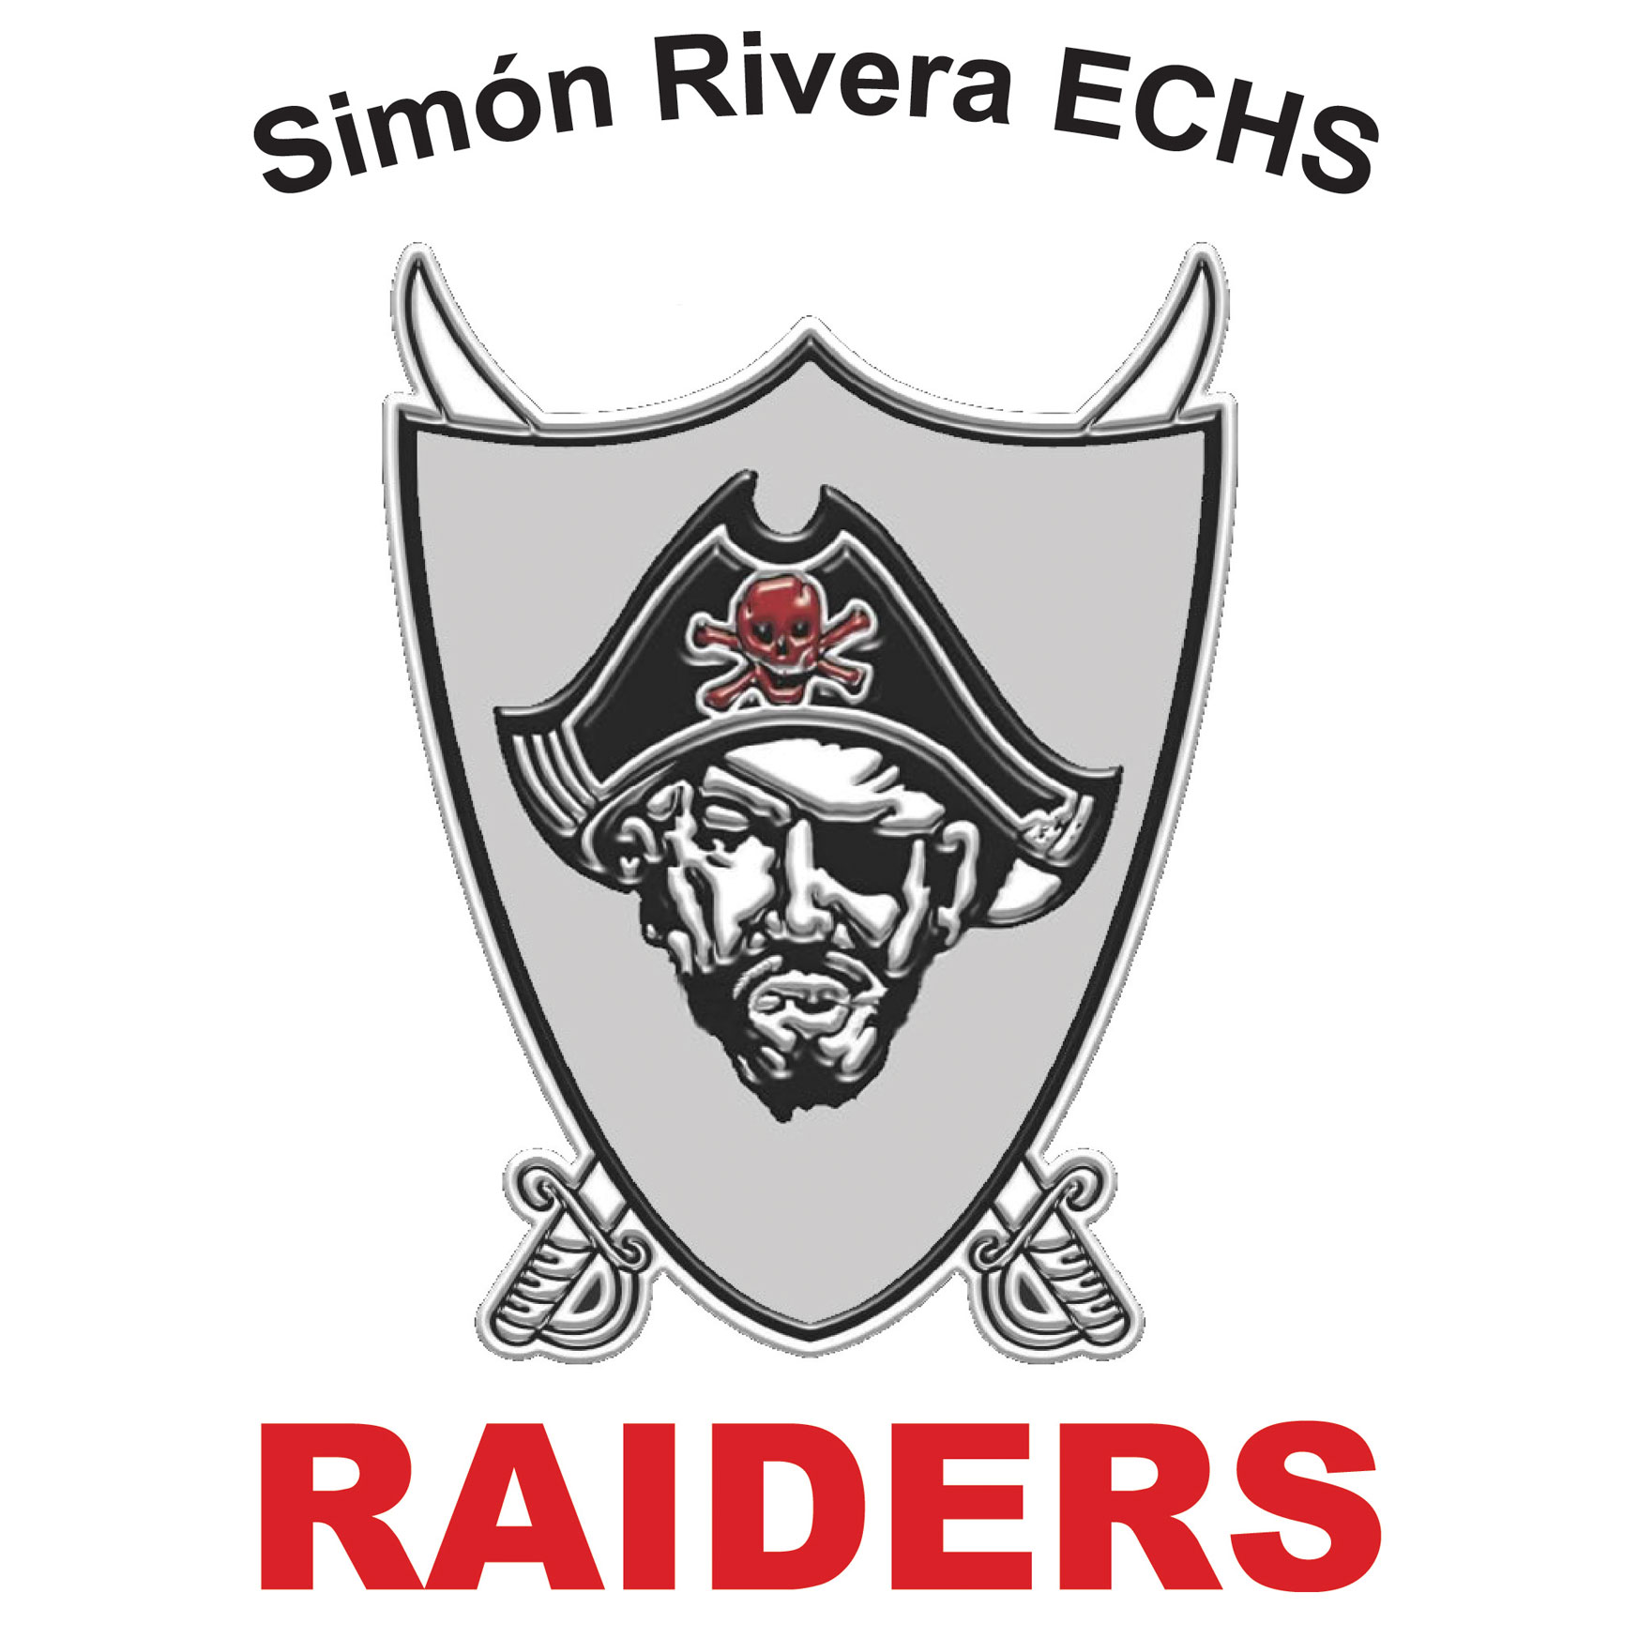
Contact Information

Mr. Joel Guzman
Email: joelguzman@bisd.us
Phone: (956) 831-8700
Class Website: http://mrguzman1.weebly.com
Conference Time: 5th period

Course Description:
English I focuses primarily on language and literature. Included will be short stories, a novel, non-fiction essays, poetry, drama, vocabulary, grammar, speaking/listening skills, and composition.
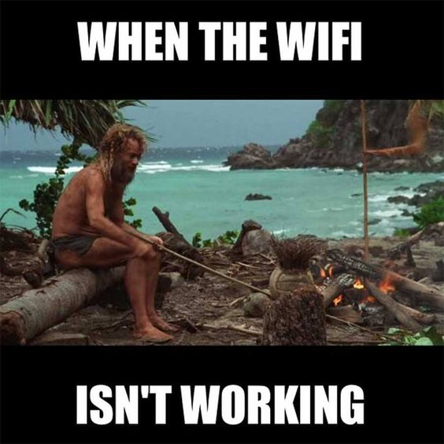

Welcome Raiders!
Use this syllabus to learn the expectations, course materials, and the course content. Please familiarize yourself with all the tools that we will be using in this class such as the required readings, SCHOOLOGY.COM, Remind notifications, and the classroom website.
Recent years have been challenging and have required us to adapt to new ways of teaching and learning. I am committed to help everyone achieve their educational goals. One factor that will help everyone this year is to communicate effectively.
We are an AVID classroom! AVID is a college readiness program designed to help students develop the skills they need to be successful in college. The program places special emphasis on growing writing, critical thinking, teamwork, organization and reading skills.
I look forward in working with every one of you to help you be successful not only in this class, but to elevate your academic prowess to meet your life-long career goals. Don’t hesitate to contact me if you have any questions.
Mr. Guzman

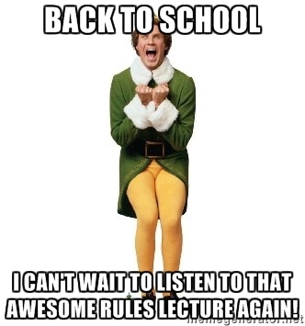
Classroom Expectations:
- RESPECT: Yourself, Your Classmates, Your Environment.
- RAISE: Your Hand, Your Confidence, Your Expectations.
- FOLLOW: Class Procedures, All Directions, School Policies.

Positive Consequences: Negative Consequences:
Verbal Praise Verbal Warning
Positive Phone Calls Home Phone Call Home
Referral

Bell Work:
- You will have bell work EVERY day.
- Bell work will be projected before you come into the classroom and you will be expected to start your bell
- work task immediately after turning in any assignments.

Pick a way to receive messages for English 1 - Honors:
https://www.remind.com/join/g97kbc

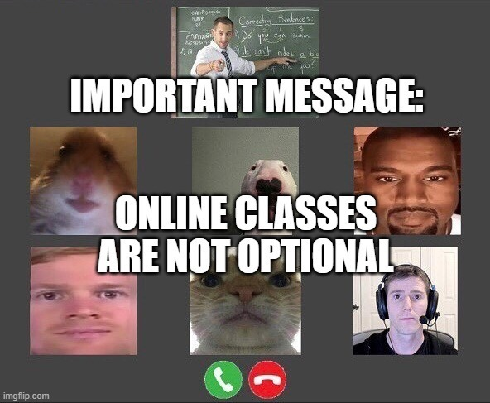

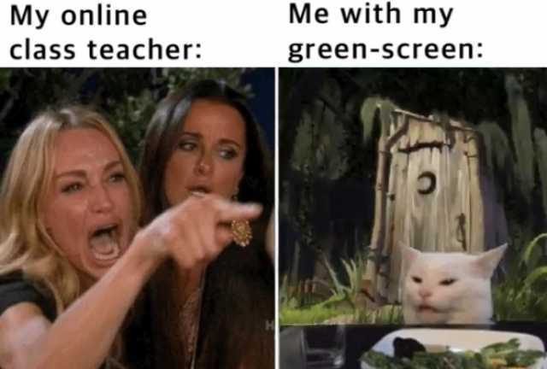

- Class starts as soon as you walk into my classroom! NOT when the bell rings.
Absences:
- Check the class website: SCHOOLOGY.COM
- Check with fellow classmates for any notes/ bell work assignments/ readings you missed.
Late/ Make-up Work:
- Late work:
  - Assignments are due at the beginning of class.
  - Your assignment is considered late if…
    - It is turned in at the end of class.
    - It is turned in at the end of the day.
    - It is turned in the day after the due date.
  - Every student will receive 3 Hardship Coupons per semester that can be redeemed for either one additional day to turn in a daily-work assignment, an extra day to study for an exam, or one extra point on the semester exam.

- Make-up work: As per BISD Student Code of Conduct
  - Assignments turned in late due to an excused absence will be accepted and graded without penalty, however, the student must do his/her due diligence in using the tools given to turn in the assignment on time.

- Retests: A retest opportunity will be offered for exams taken in class on which the student scored less than a 70.
  - The student will be notified of a failing test grade no later than 5 days after the test is given.
Electronic Devices:
The use of electronic devices is not permitted in the classroom unless the teacher has stated otherwise.
- 1st offense verbal warning
- 2nd offense device will be picked up and turned in to the front office.

Course Materials
- 1 Composition book
- Folder
- Pens (red, blue, black); Pencils
- Loose-leaf notebook paper
- USB drive
- Other materials will be needed throughout the year such as poster board, art supplies, and other related items.

Tardy Policy:
Per the BISD Handbook:
- 1st Tardy Verbal warning and a phone call home.
- 2nd-4th Tardy Teacher assigned lunch detention.
- 5th Tardy Referral to office for after school detention.
- You walk into class after the bell rings without a pass.
Plagiarism:
Plagiarism, or, the copying of someone else’s work and passing it off as your own, will not be tolerated. If you plagiarize, you will receive an automatic “0” on an assignment and you will not be allowed to make up the assignment.
Grading Policy

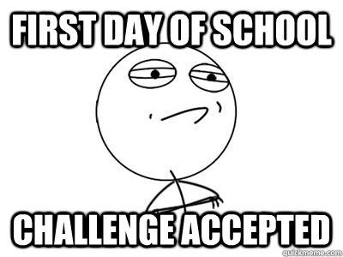
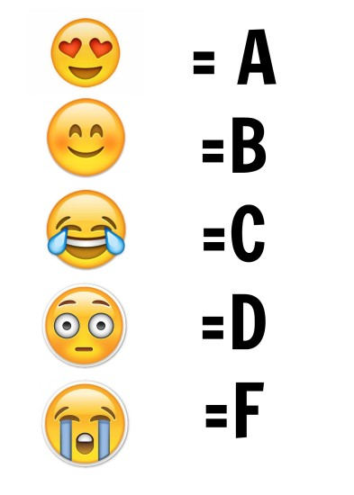
- 90% - 100%

- 80% - 89%

- 70% - 79%

- 60% - 69%

- 59% - or less
- 90% - 100%

- 80% - 89%

- 70% - 79%

- 60% - 69%

- 59% - or less

